**How to Create an App Password for Gmail?**

Two-step verification in Gmail is a security feature that helps users protect their account when using third-party applications to log in. Some third-party apps don't accept your regular Gmail password, so Gmail provides a solution called "App Passwords." These App Passwords are automatically generated by Gmail and allow you to log in to specific apps securely. Essentially, an App Password is a 16-digit code that grants access to your Gmail account via non-Google apps or devices. It's important to note that you can only create an App Password if you've already enabled two-step verification for your Gmail account. In this guide, we'll explore how to generate an App Password within your Gmail account so that you can access your Gmail account through other applications.

**The Importance of App Passwords**

App Passwords are essential for maintaining the safety of your Gmail account, especially when you're using apps that aren't made by Google. They provide an extra layer of security. In simple terms, if you're trying to log in to an app that doesn't have the option to "Sign in with Google," that's when you would use an App Password.

**Generating App Passwords**

To generate an App Password in Gmail, you must first enable 2-step verification. If you haven't already turned on 2-step verification in Gmail, you can follow these steps to set it up.

1. **Sign in to Gmail**: Open your web browser and go to the Gmail website (<https://mail.google.com>). Sign in to your Gmail account if you're not already logged in.
2. **Access Your Google Account Settings**: Click on your profile picture in the upper-right corner of the Gmail interface. In the dropdown menu, select "Manage your Google Account." This will take you to your Google Account settings.

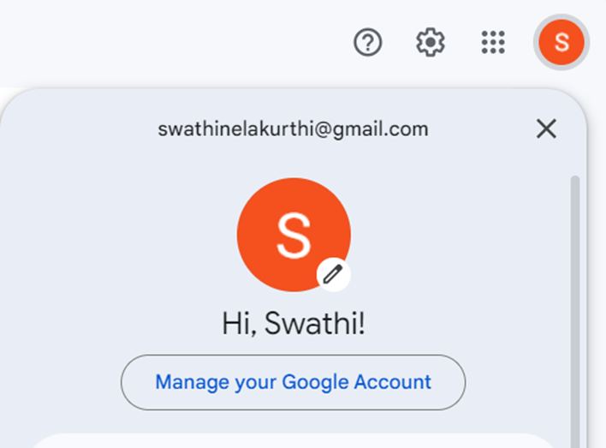

1. **Go to Security**: In the left sidebar, click on the "Security" tab. This section allows you to manage your account's security settings.
2. **Enable 2-Step Verification**: Under the "How you sign in to Google" section, you should see an option labelled "2-Step Verification." Click on the "2-Step Verification" button.

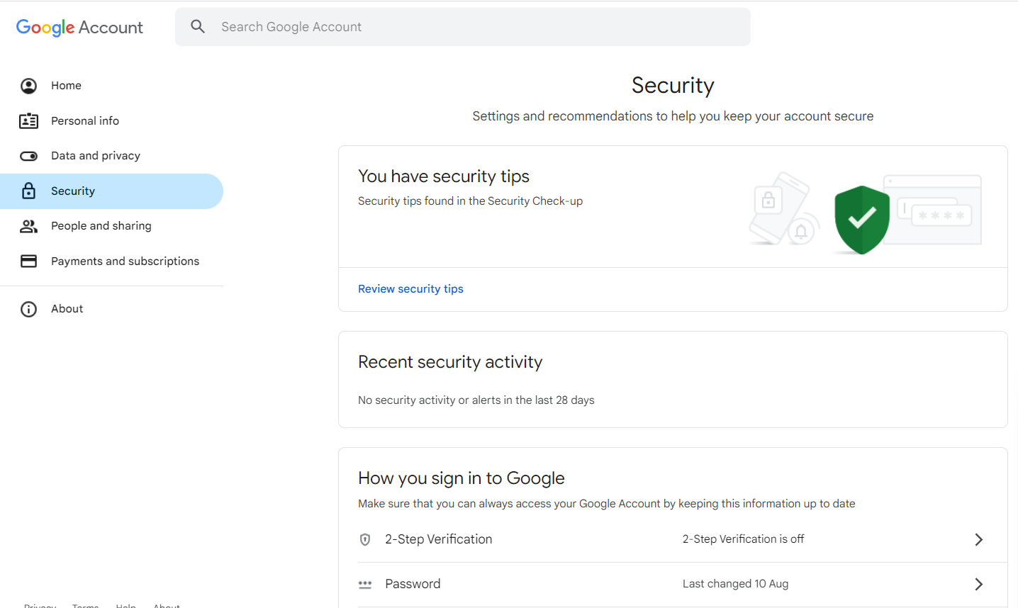

1. **Start the Setup Process**: Click the "Get Started" button to begin the 2-step verification setup.

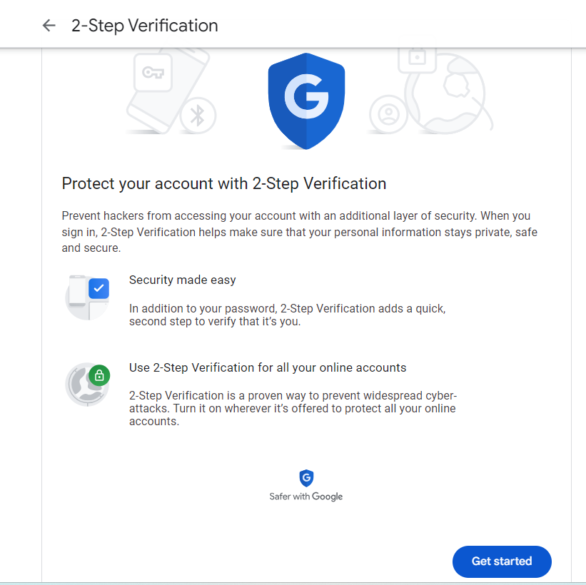

1. **Enter Your Password**: You may be asked to enter your Google Account password for security verification. Provide your password and click "Next.
2. **Verify Your Phone**: If you haven't already linked a phone number to your Google Account, you will be prompted to add one. Provide your phone number. Google will send a verification code to this phone number when you log in from an unrecognized device. Select your country, enter your phone number, and click "Next." Google will send a verification code to your phone.

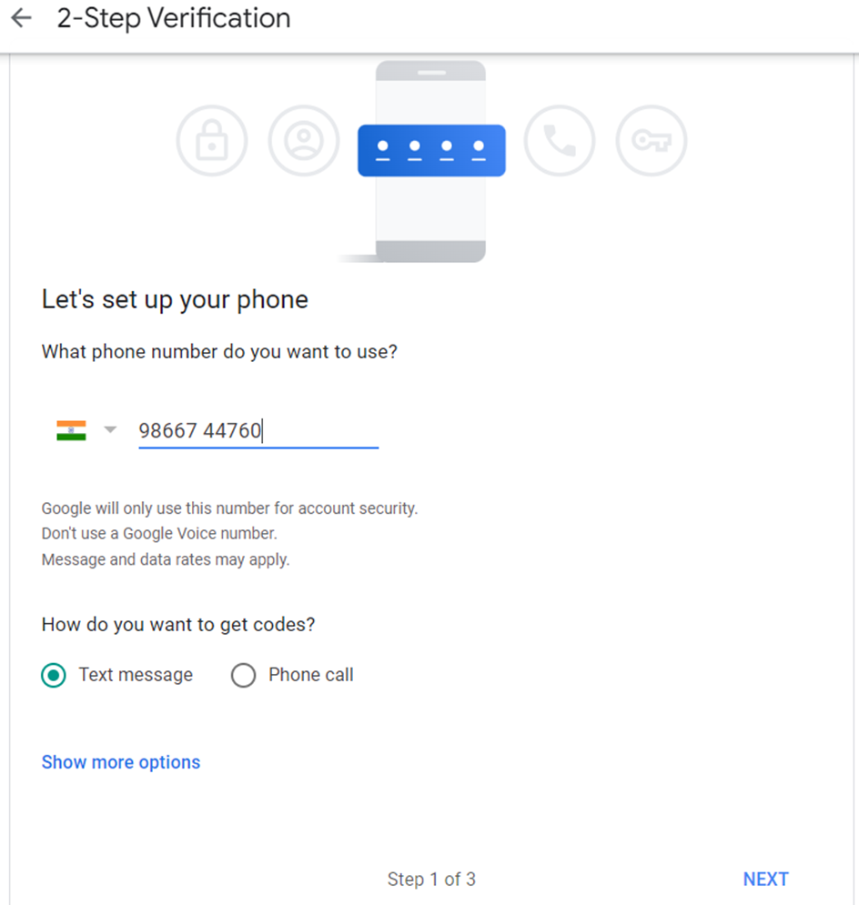

1. **Enter Verification Code**: Check your mobile device for the verification code and enter it in the space provided on the computer screen. Click "Next."

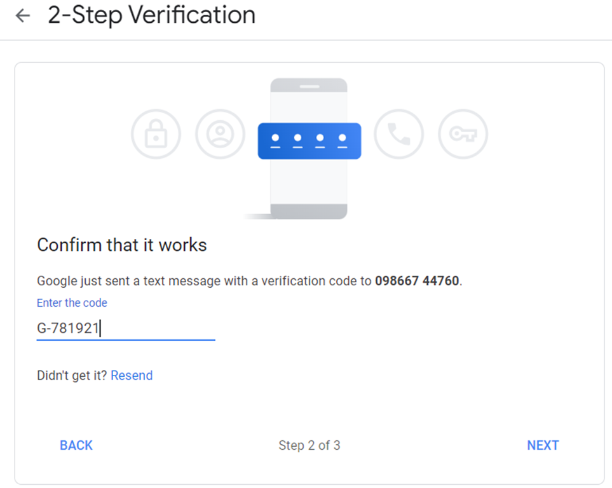

1. **Turn on 2-Step Verification**: After entering the verification code, you can enable 2-step verification by toggling the switch to the "On" position. This will activate the feature for your Gmail account.

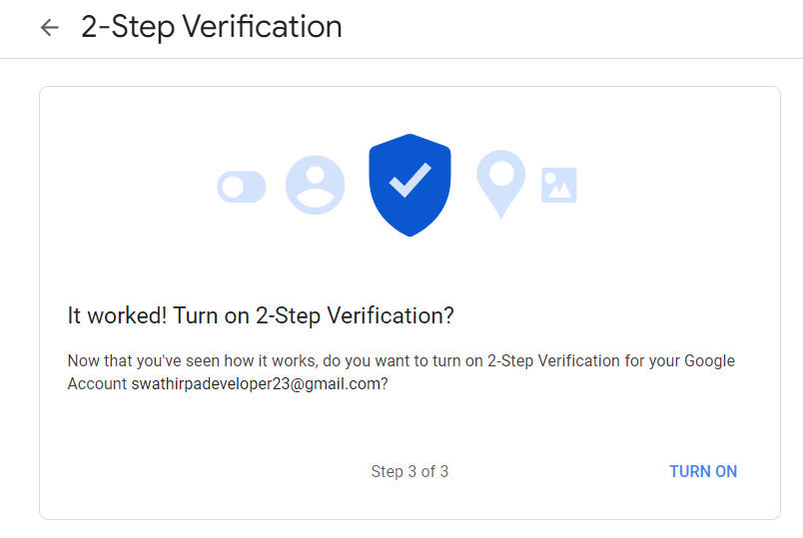

From now on, when you log in to your Gmail account from an unrecognized device or application, you'll need to enter a verification code sent to your registered phone number to access your account. This adds an extra layer of security to your Gmail account and helps protect it from unauthorized access.

**Creating App Passwords**

1. **Access Your Google Account Settings**: Once you've activated 2-step verification, you can create an App Password by following these steps:
   1. Click on your profile picture located in the upper-right corner of the Gmail interface.
   2. From the dropdown menu, choose "Manage your Google Account" to access your Google Account settings in the next window.
2. **Navigate to Security**: Click the **Security** tab in the left pane, and then scroll down to ‘**How you Sign in to Google**’. Click on “**2-Step Verification**”

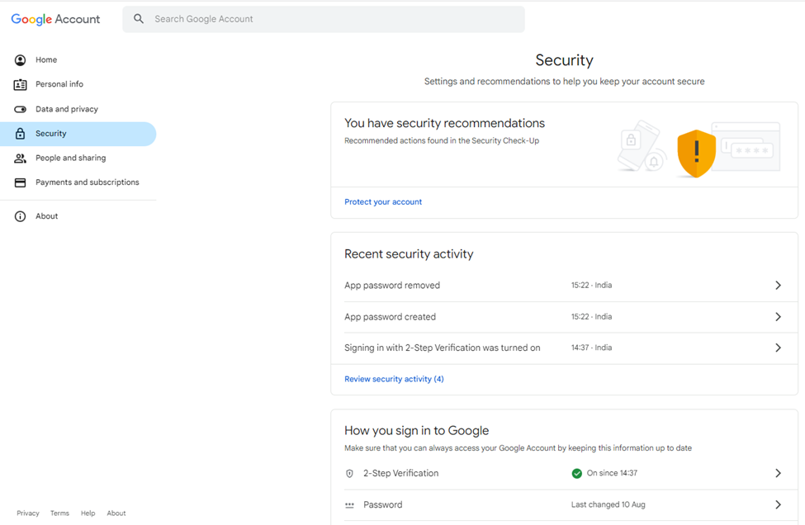

1. **Enter Your Google Account Password**: You will be prompted to enter your Google Account password for security verification. Provide your password and click "Next."

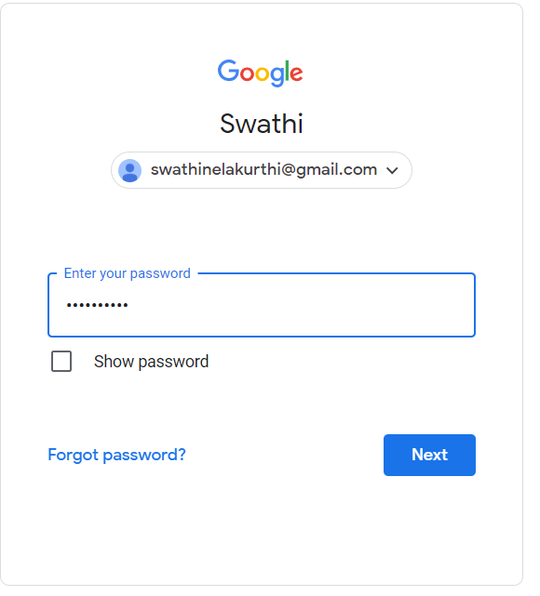

1. **Go to App Passwords**:
   1. Scroll down to the page.
   2. You should see an option labelled "App passwords". Click on it.

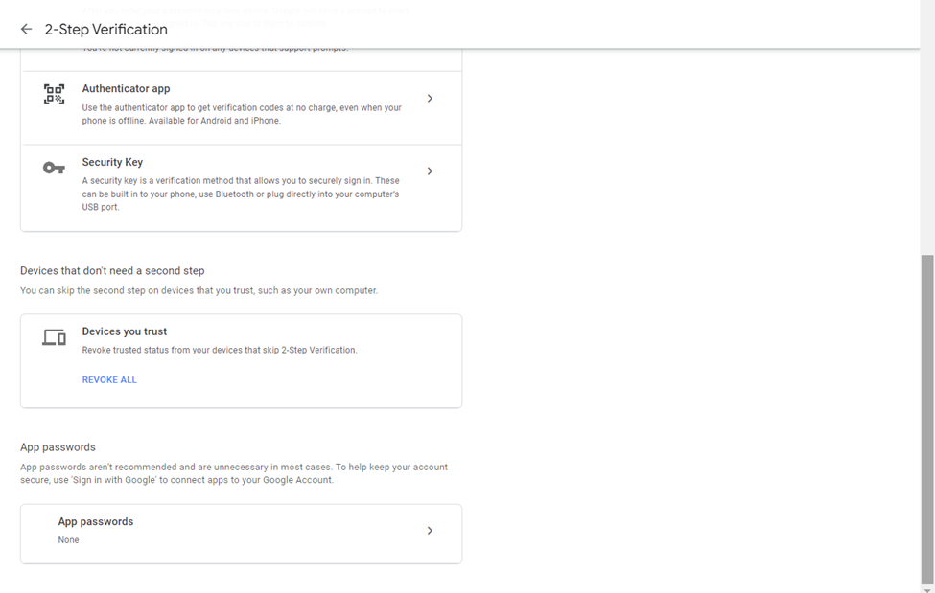

1. **Generate App Password:** Provide App name and click on Create

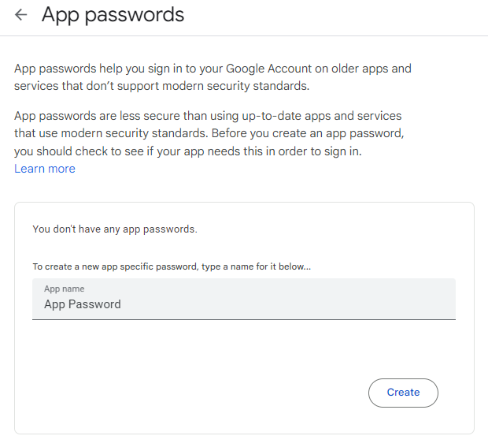

1. **Copy and Use the App Password**:
   1. The generated App Password will be displayed on the screen.
   2. Copy this App Password to your clipboard and use it in the settings of the third-party application or device where you need to enter your Gmail password.
   3. Note that App Passwords are one-time use codes, so keep them secure.

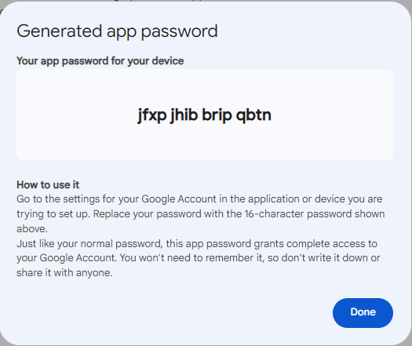

Here's how you can generate an App Password for your Gmail account.

**Conclusion**

In conclusion, enabling two-step verification offers added security to your Gmail account, and App Passwords help safeguard your account from misuse. This article has covered the process of enabling two-step verification and creating App Passwords.